Course Code: Ethical Hacking Laboratory

Software Required: Kali Linux (Latest Version)

Name: Sk Arshad Basha

Reg No.:192312336

Experiment 1

Basic File and User Management Commands

Aim
To execute and understand the usage of rm, users, and tree commands in Kali Linux.

Procedure
- Open Kali Linux Terminal.
- Create a sample file.
- Execute the rm command.
- Execute the users command.
- Execute the tree command.
Commands:
Touch test.txt
Ls
Rm test.txt
User
Tree

Output

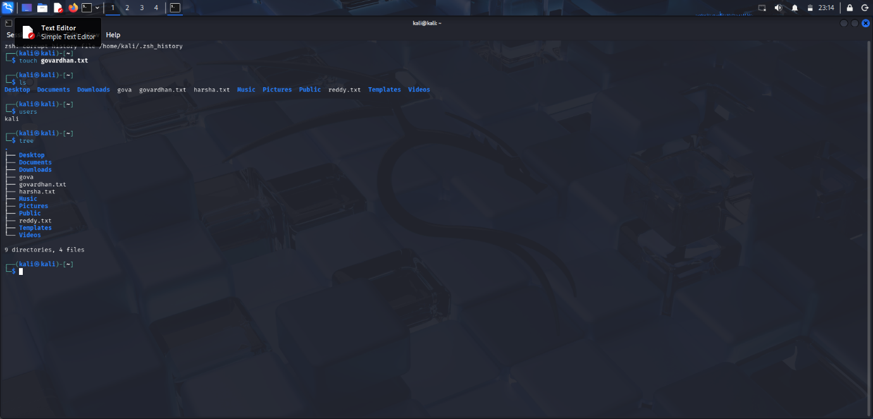

Result
Successfully executed rm, users, and tree commands in Kali Linux.

Experiment 2

File Viewing Commands

Aim
To execute and understand the usage of less, more and vi commands.

Procedure
- Create a text file.
- Open the file using less.
- Open the file using more.
- Edit the file using vi.
Commands:
less test.txt
more test.txt
vi test.txt
Output
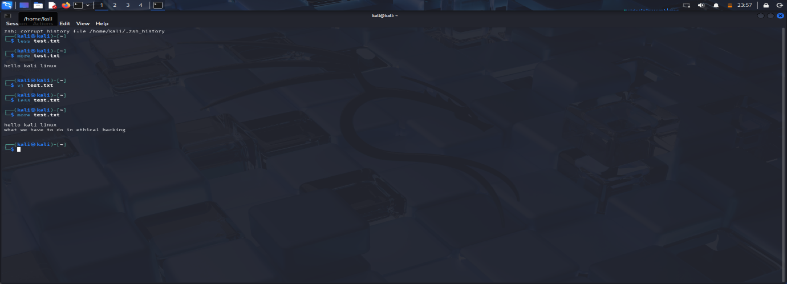

Result
Successfully executed file viewing and editing commands.

Experiment 3

Tree, Head and Tail Commands

Aim
To execute and understand the usage of tree, head, and tail commands.
Procedure
- Create a text file containing multiple lines.
- Execute the head command.
- Execute the tail command.
- Display directory structure using tree.
Commands:
Tree
Head test.txt
Tali test.txt

Output

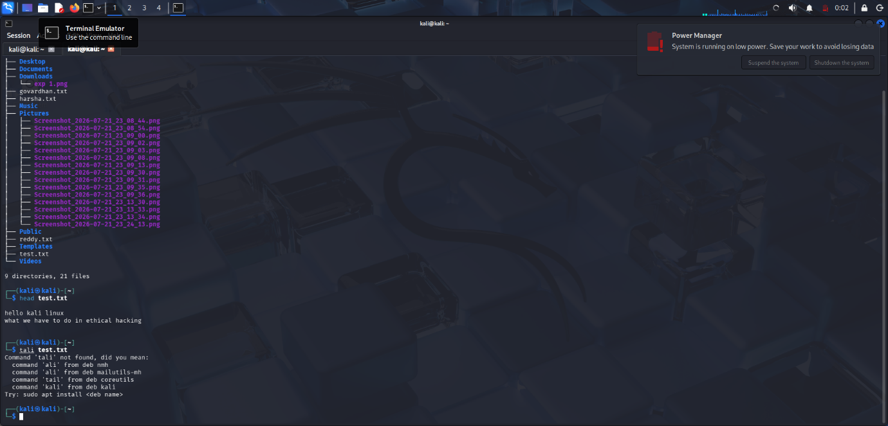

Result
Successfully executed tree, head, and tail commands.

Experiment 4

Directory and File Display Commands

Aim
To execute ls, cat, and mkdir commands.
Procedure
- Create a directory using mkdir.
- List files using ls.
- Create a text file.
- Display file contents using cat.
Commands:
Ls
Cat /etc/hostname
Mkdir DemoFolder
ls
Output:
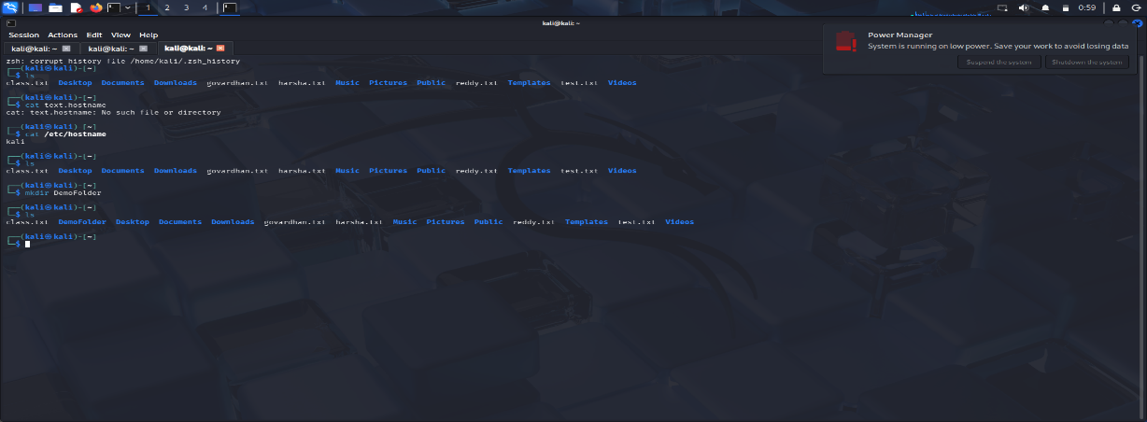

Result
Successfully executed ls, cat, and mkdir commands.

Experiment 5

System Information Commands

Aim
To execute uptime, date, and mv commands.
Procedure
- Check system uptime.
- Display current date.
- Rename a file using mv.
Commands:
Uptime
Date
Touch file1.txt
Mv file1.txt file2.txt
Ls

Output:
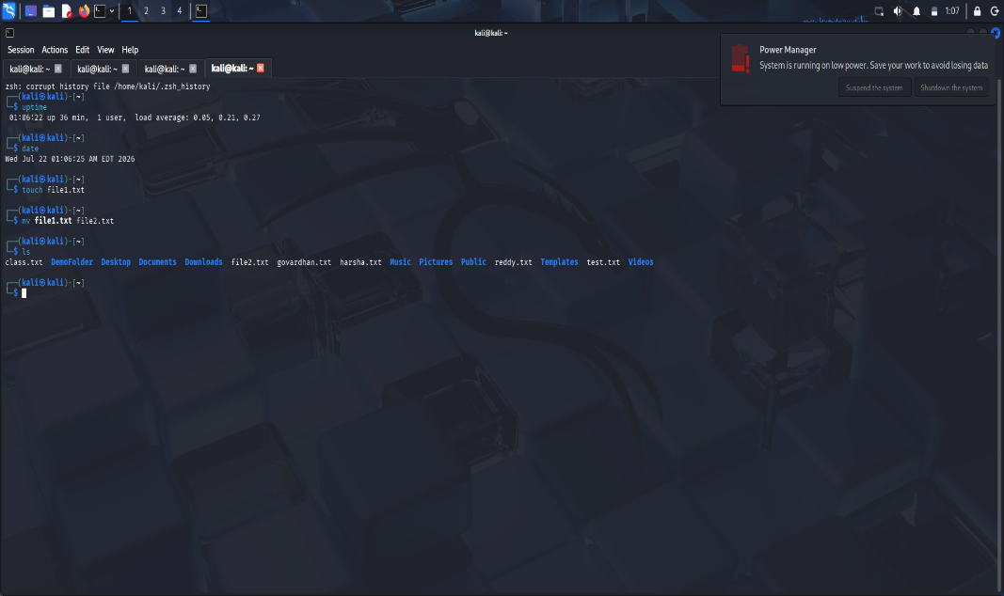

Result
Successfully executed uptime, date, and mv commands.

Experiment 6

File Creation and Download Commands

Aim
To execute touch, pwd, and wget commands.

Theory

touch Command
Creates an empty file.
touch sample.txt

pwd Command
Displays current working directory.
pwd

wget Command
Downloads files from the internet.
wget https://example.com/file.zip

Procedure
- Create a file using touch.
- Display current directory using pwd.
- Download a sample file using wget.
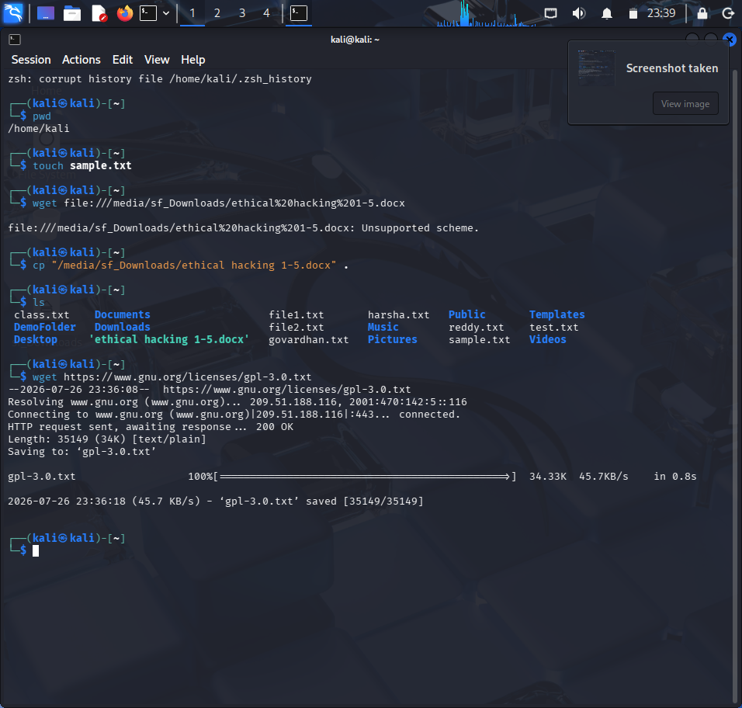

Result
Successfully executed touch, pwd, and wget commands.

Experiment 7

Navigation and Copy Commands

Aim
To execute cd, cp, and ls commands.

Theory

cd Command
Changes the current directory.
cd Documents

cp Command
Copies files and directories.
cp file1.txt backup.txt

Procedure
- Navigate between directories using cd.
- Copy files using cp.
- Verify copied files using ls.
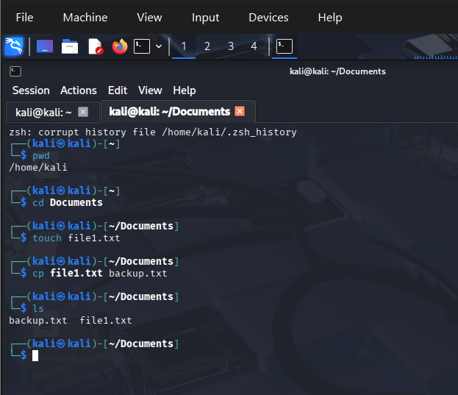

Result
Successfully executed cd, cp, and ls commands.

Experiment 8

Nmap Service Version and OS Detection

Aim
To perform service version detection and operating system identification using Nmap.

Theory
Nmap (Network Mapper) is an open-source network scanning tool used for network discovery and security auditing.

Commands

i) Detect Service Versions
nmap -sV 192.168.1.10
Description:
Determines the versions of services running on target ports.

ii) Aggressive Scan
nmap -A 192.168.1.10
Description:
Performs OS detection, version detection, script scanning, and traceroute.

iii) Operating System Detection
sudo nmap -O 192.168.1.10
Description:
Identifies the operating system running on the target host.

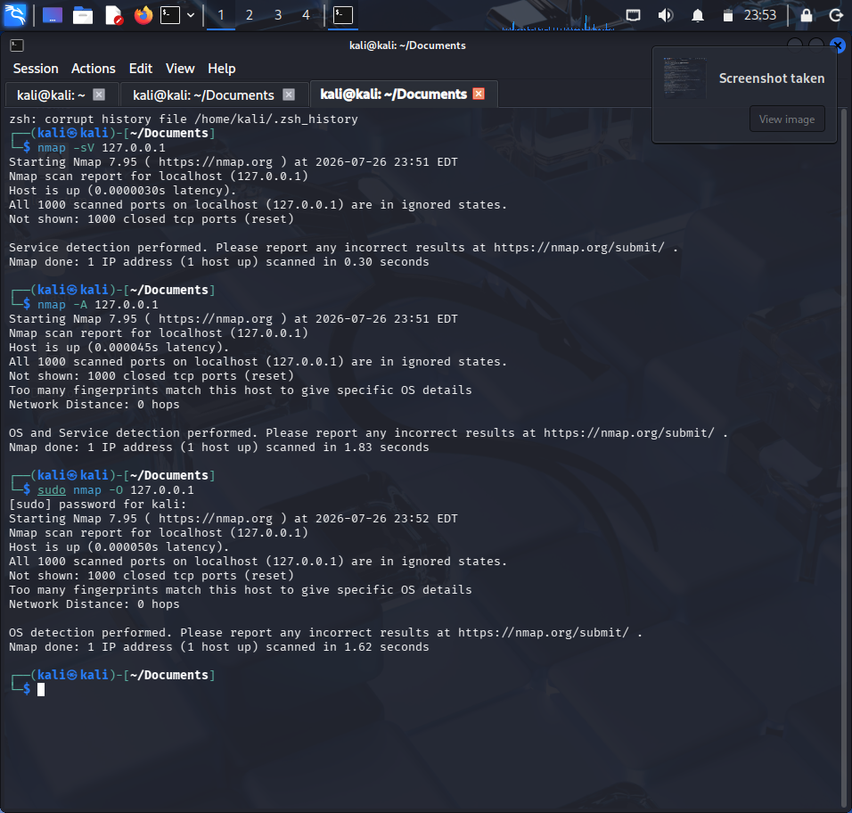

Result
Successfully performed service version detection and OS identification using Nmap.

Experiment 9

Nmap Timing and Performance Commands

Aim
To perform IDS evasion and timing scans using Nmap.

Theory
Timing options control the speed and stealthiness of Nmap scans.

Commands

i) Polite IDS Evasion
nmap -T2 192.168.1.10
Description:
Slows down scanning to reduce the chance of detection.

ii) Normal Scan
nmap -T3 192.168.1.10
Description:
Default balanced scanning speed.

Procedure
- Identify target IP address.
- Execute Nmap timing commands.
- Observe scan duration and results.
- Compare scan speeds.
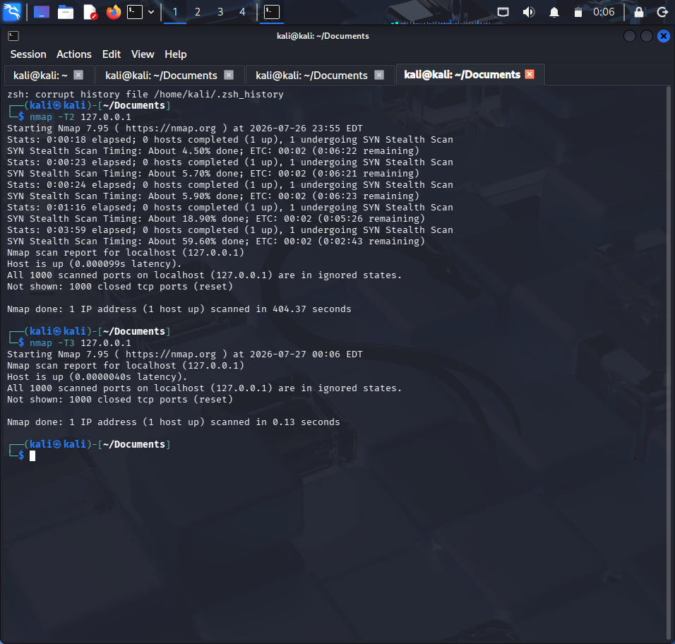

Result
Successfully executed Nmap timing and performance scans in Kali Linux.

Experiment 10: Free, Sort and History Commands
Aim:
To execute and understand the usage of Free, Sort, and History commands in Kali Linux.
Commands:
free
free -h
sort file.txt
sort -r file.txt
history
history 10
Procedure:
- Open Terminal in Kali Linux.
- Execute the free command to view memory usage.
- Create a text file and use the sort command.
- Execute the history command to display previously executed commands.
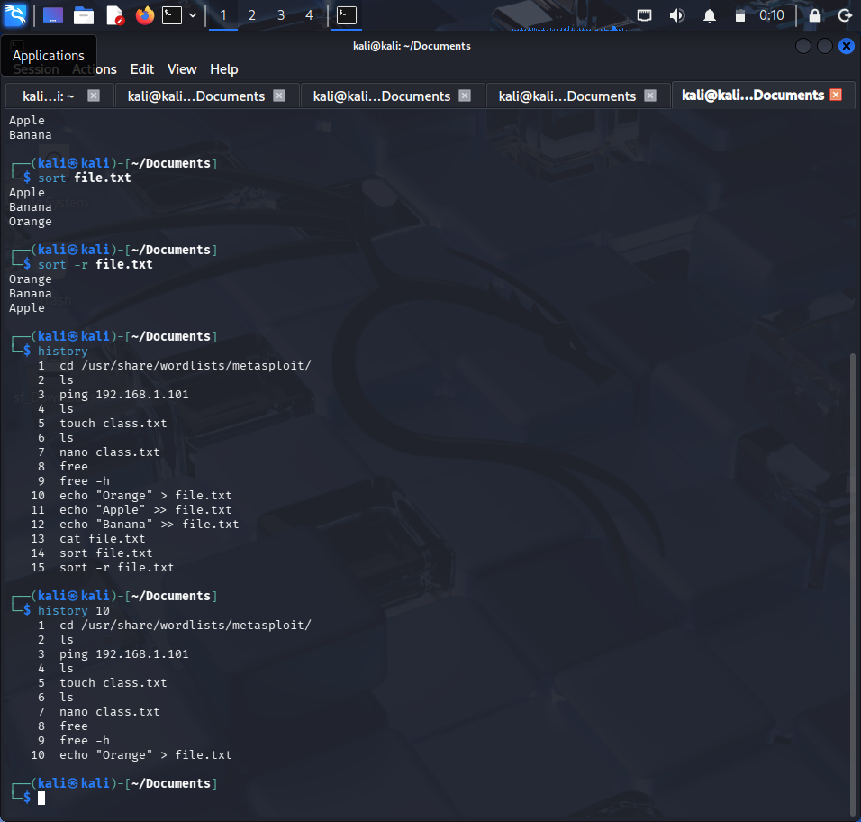
Result:
Successfully executed Free, Sort, and History commands in Kali Linux.

